Experiment 6

Aim:
Implement Parser Generator Tool : YACC
- Simple Calculator
- Recognize nested IF stmt and display levels
- Program to recognize a valid variable in C language

Theory:
YACC stands for Yet Another Compiler Compiler. YACC provides a tool to produce a parser for a given grammar. YACC is a program designed to compile a LALR (1) grammar. It is used to produce the source code of the syntactic analyzer of the language produced by LALR (1) grammar. The input of YACC is the rules or grammar and the output is a C program.
Yacc generates C code for syntax analyzer, or parser.
Yacc uses grammar rules that allow it to analyze tokens from Lex and create a syntax tree.
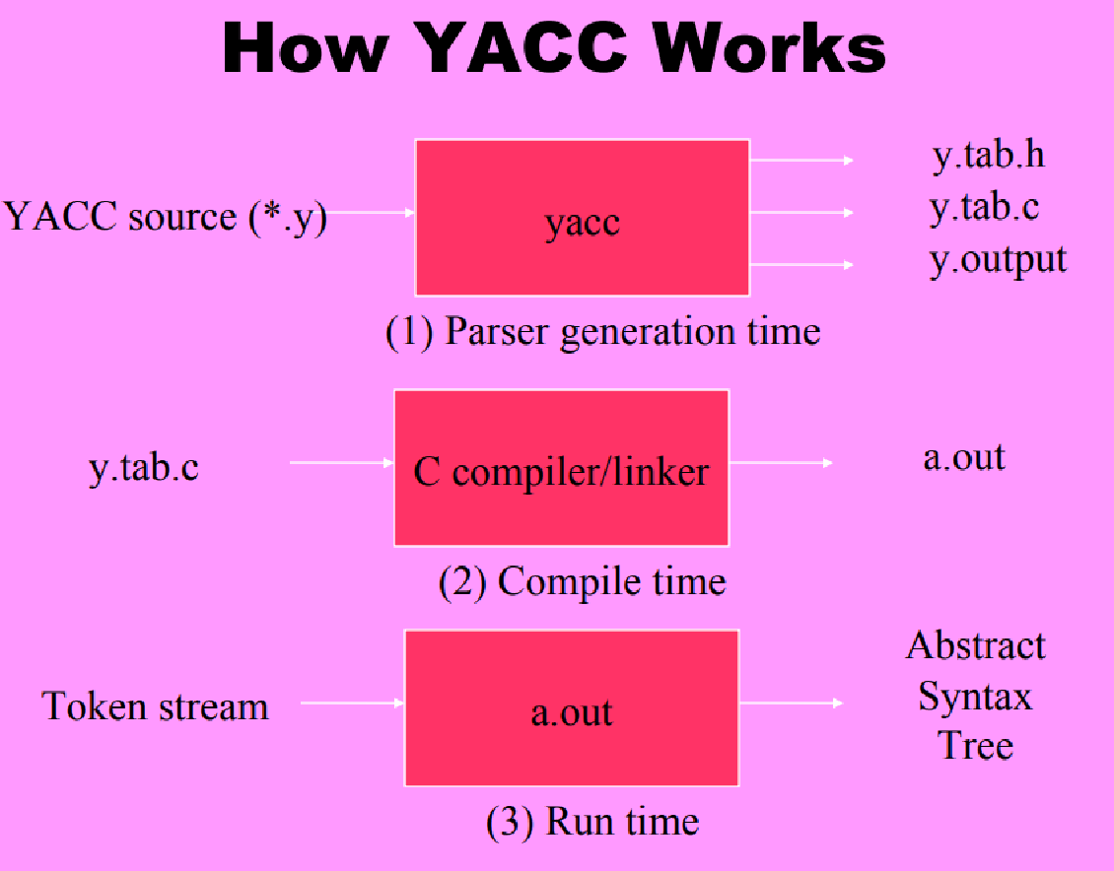
YACC file Format:
%{
C declarations
%}
yacc declarations
%%
Grammar rules
%%
Additional C code
Comments enclosed in /* ... */ may appear in any of the sections.

Definition Section:
%{
#include <stdio.h>
#include <stdlib.h>
%}

% token ID NUM
% start expr

- The first non-terminal specified in the grammar specification section.
- To overwrite it with %start declaration.
%start non-terminal
YACC Declaration Summary:
- `%start’
  - Specify the grammar's start symbol
- `%union’
  - Declare the collection of data types that semantic values may have
- `%token’
  - Declare a terminal symbol (token type name) with no precedence or associativity specified
- `%type’
  - Declare the type of semantic values for a nonterminal symbol
- `%right’
  - Summary Declare a terminal symbol (token type name) that is right-associative
- `%left’
  - Declare a terminal symbol (token type name) that is left associative
- `%nonassoc’
  - Declare a terminal symbol (token type name) that is non associative (using it in a way that would be associative is a syntax error, ex: x op. y op. z is syntax error)

%right ‘=‘
%left ‘<‘ '>’ NE LE GE
%left '+’ ‘-‘
%left '*’ '/’
%noassoc UMINUS

To execute a Yacc program on Windows, the steps are:
- Install Cygwin or MinGW:MinGW (Minimalist GNU for Windows) provides a native Windows port of the GNU Compiler Collection (GCC) and other utilities. You can install Yacc (`bison`) through MinGW.
- Install Yacc (Bison):If you've installed MinGW, you can install Bison using its package manager or manually download and install it from the MinGW website.
- Write your Yacc code:Use a text editor (e.g., Notepad, Visual Studio Code, etc.) to write your Yacc code and save it with a `.y` extension.
- Open Command Prompt:Press `Win + R`, type `cmd`, and press Enter to open Command Prompt.
- Navigate to the directory containing your Yacc code:Use the `cd` command to navigate to the directory where your Yacc code is saved. For example:
cd path\to\your\directory
- Run Yacc (Bison):Use the following command to run Yacc (Bison) on your Yacc code:
bison -d your_yacc_file.y
This command generates C code for the parser. The `-d` option tells Bison to generate a header file (`your_yacc_file.tab.h`) along with the parser code.
- Compile the generated C code:
Use a C compiler like GCC to compile the generated C code:
gcc -o your_output_executable your_yacc_file.tab.c -ly -ll
- `-o your_output_executable` specifies the name of the output executable.
- `your_yacc_file.tab.c` is the generated C code.
- `-ly -ll` are libraries that may be required for certain Yacc programs. `-ly` is for the parser and `-ll` is for the lexer (if you have one).
- Run the executable:
Execute the generated executable by typing its name in the Command Prompt and pressing Enter.

Code:
Simple Calculator:
Calci.l
%{
#include<stdio.h>
#include<math.h>
#include "y.tab.h"
%}
%%
[0-9]+ {yylval.dval=atoi(yytext); return NUMBER; }
[\n] {return 0;}
[ \t] {;}
. {return yytext[0];}
%%
int yywrap(void)
{
return 1;
}
void yyerror(char *str)
{ printf(" Error : %s",str);
}
int main()
{
printf("Enter Expression => ");
yyparse();
return(0);
}
Calci.y
%{
#include<stdio.h>
int yylex(void);
%}
%union
{
float dval;
}
%token <dval> NUMBER
%left '+' '-'
%left '*' '/'
%nonassoc UMINUS
%type <dval> exp
%%
state : exp {printf("Answer = %f",$1);}
;
exp : NUMBER
| exp '+' exp {$$=$1+$3;}
| exp '-' exp {$$=$1-$3;}
| exp '*' exp {$$=$1*$3;}
| exp '/' exp {$$=$1/$3;}
| '('exp')' {$$=$2;}
| '-' exp %prec UMINUS {$$=-$2;}
;
%%
OUTPUT:
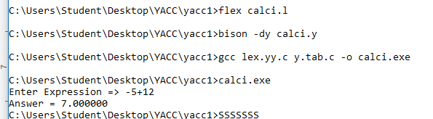
Recognize nested IF stmt and display levels:
If.y
%{
#include<stdio.h>
#include<stdlib.h>
int count=0;
%}
%token IF RELOP S NUMBER ID NL
%%
stmt: if_stmt NL {printf("No. of nested if statements=%d\n",count);exit(0);};
if_stmt : IF'('cond')''{'if_stmt'}'
{count++;}
|S
;
cond: x RELOP x
;
x:ID | NUMBER
;
%%
int yyerror(char *msg)
{
printf("the statement is invalid\n");
exit(0);
}
main()
{
printf("enter the statement\n");
yyparse();
}
If.l
%{
#include "y.tab.h"
%}
%%
"if" {return IF;}
[sS][0-9]* {return S;}
"<"|">"|"=="|"<="|">="|"!=" {return
RELOP;}
[0-9]+ {return NUMBER;}
[a-z][a-zA-Z0-9_]* {return ID;}
\n {return NL;}
. {return yytext[0];}
%%
int yywrap(){return 1;}
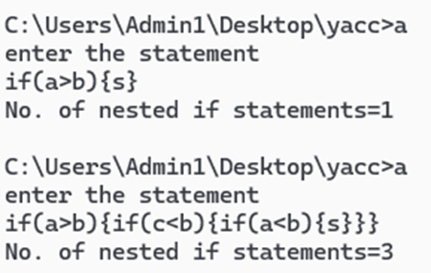

Program to recognize a valid variable in C language:
var.l
%{
#include "y.tab.h"
%}
%%
[a-zA-Z_][a-zA-Z_0-9]* return letter;
[0-9] return digit;
. return yytext[0];
\n return 0;
%%
int yywrap()
{
return 1;
}
var.y
%{
#include<stdio.h>
int valid=1;
%}
%token digit letter
%%
start : letter s
s : letter s
| digit s
|
;
%%
int yyerror()
{
printf("\nIts not a identifier!\n");
valid=0;
return 0;
}
int main()
{
printf("\nEnter a name to tested for identifier ");
yyparse();
if(valid)
{
printf("\nIt is a identifier!\n");
}
}
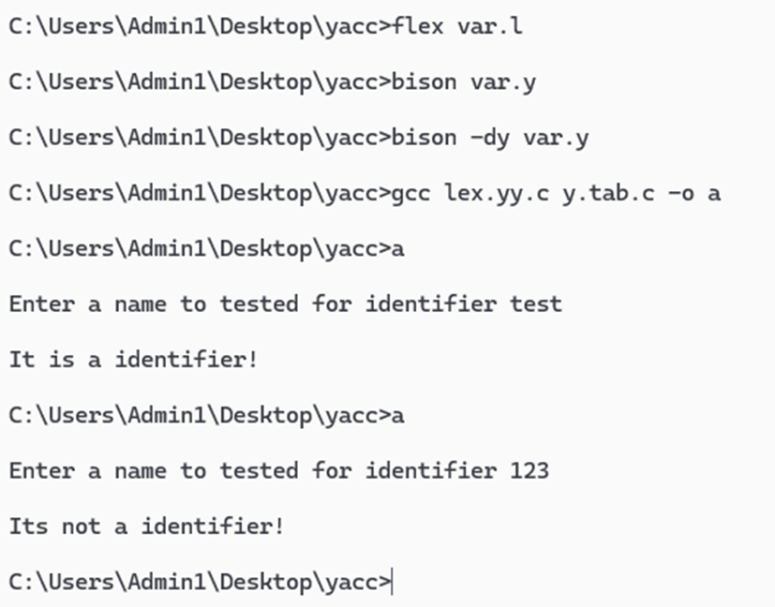

Conclusion:
In conclusion, the implementation of Yacc in C for parsing source code effectively showcased the pivotal role of Yacc in compiler design. The program adeptly tackled a range of tasks including parsing arithmetic expressions for a simple calculator, recognizing nested IF statements and determining their levels, and identifying valid variables in C language syntax. By successfully handling these tasks, the Yacc program underscored the significance of Yacc in facilitating syntactic analysis and code generation within the compilation process. Just as Lex is essential for lexical analysis, Yacc's contribution in parsing and syntax analysis is paramount, solidifying its indispensable role in the comprehensive compilation workflow.

